# 

# First Time Setup

**For all installs, just click next through them and don’t change the default settings unless you know what you are doing.**

### Mass Profiler

* 1. This should have been installed by the Agilent service engineer upon instrument set up, however it is easily installed on other machines with the software cd

### Python

* 1. Download Python 3.6 from [this link](https://www.python.org/downloads/release/python-360/) (Very bottom of the page)
     1. ‘Windows x86-64 executable installer’ for Windows 10
  2. Run the installer
  3. Be sure to select the check box that adds Python to the PATH
  4. I recommend using [Anaconda](https://anaconda.org/anaconda/python) for a Python IDE, as it is user-friendly and comes pre-installed with many of the dependencies used by MSIC. Other options include PyCharm or any other python interpreter
  5. Whichever python interpreter you are using, make sure it uses the same version of Python as you have installed

### Skyline

* 1. Download [Skyline Daily](https://skyline.ms/project/home/software/Skyline/daily/register-form/begin.view)
     1. You will be required to create an account with Skyline to do this (you’ll rarely get emails)
  2. Run setup.exe
  3. 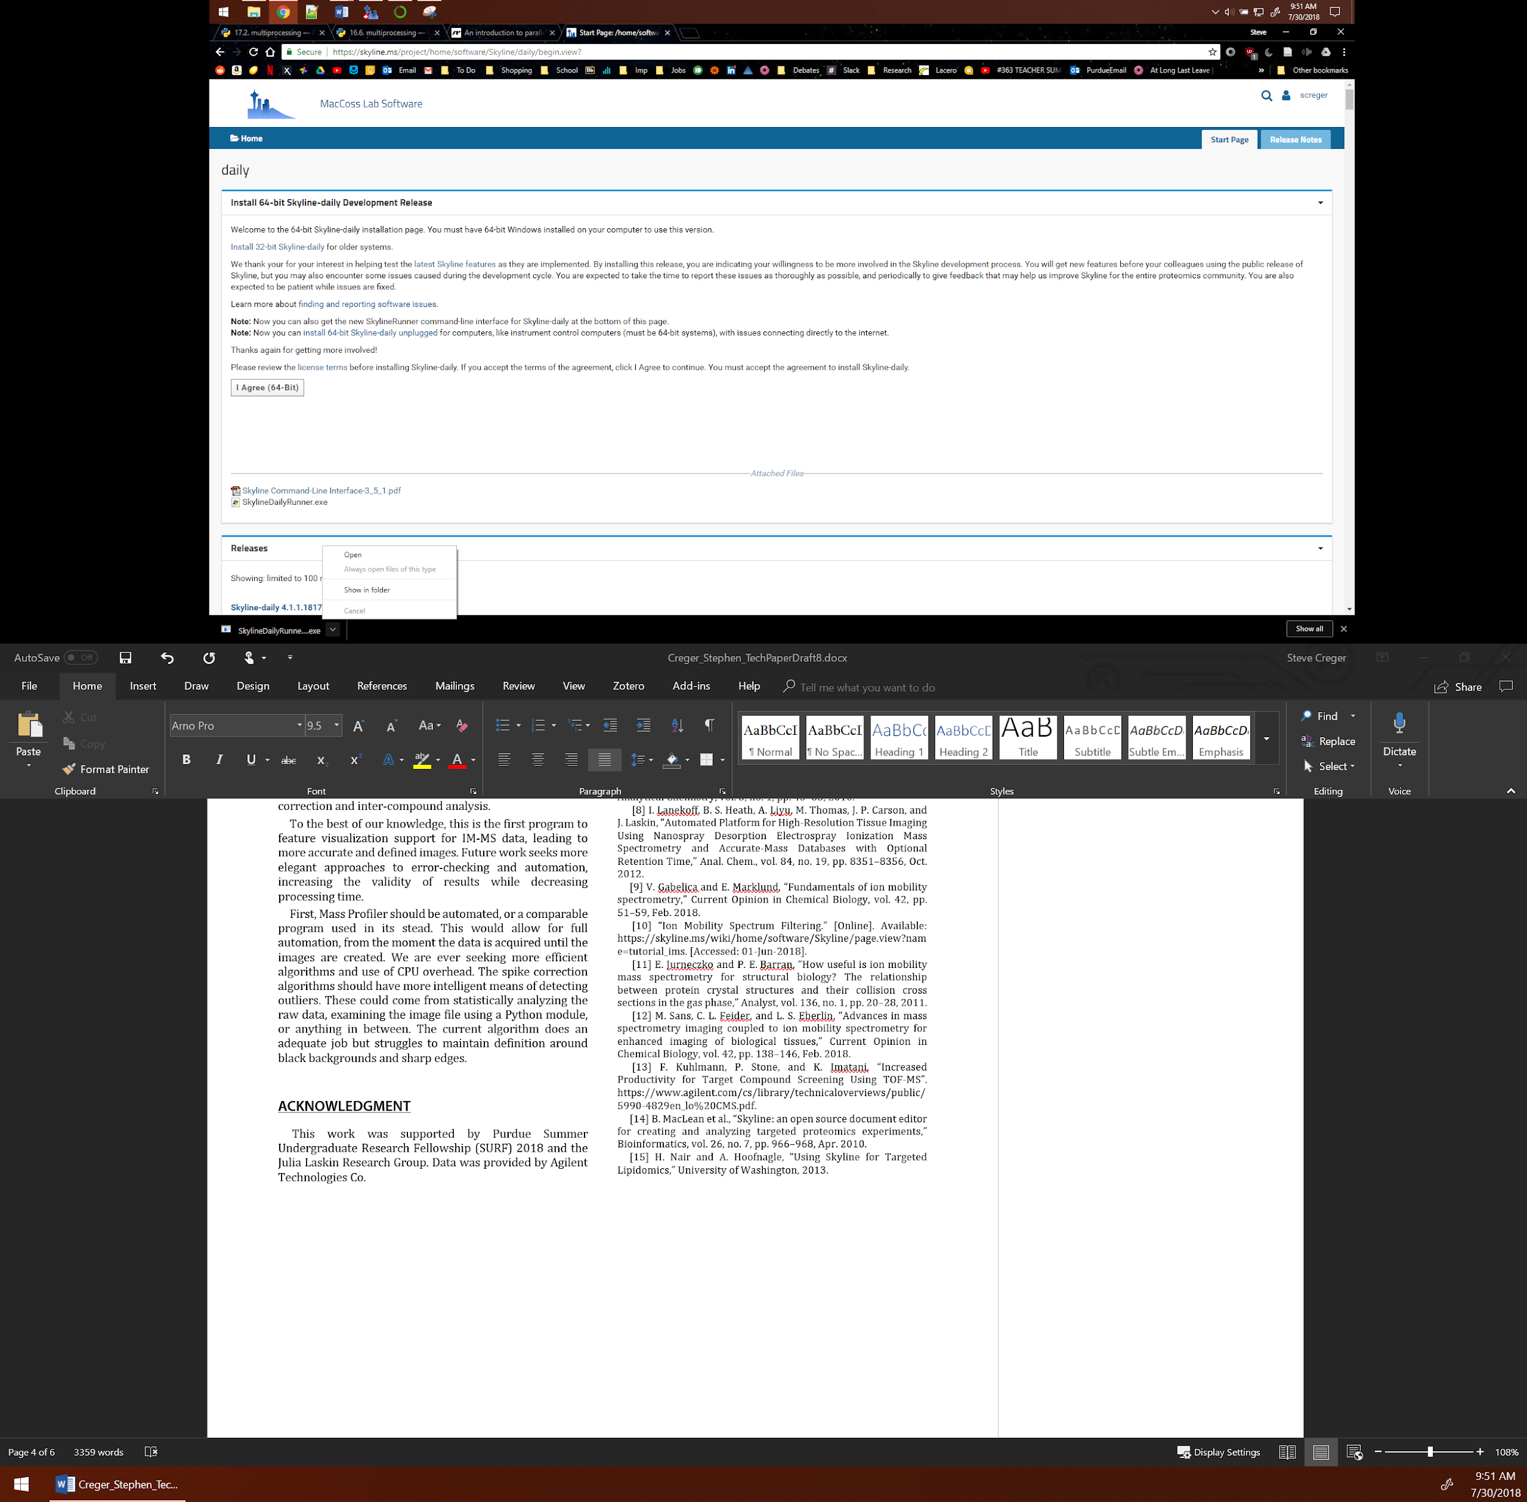Download SkylineDailyRunner.exe as well (lower down the same page as the main download), make note of the location of the download (in Chrome, you can click the arrow and then select ‘Show in Folder’). Copy and paste it into the MSIC_Master folder if not already there.

### PATH

* 1. Hit the windows key (or click the start button), search for ‘Edit the system environment variables,’ press enter or click on the entry
  2. Click ‘Environment variables’ in the ‘System Properties’ menu that popped up
  3. Double-click Path under User variables
  4. **You should have entries for Skyline-daily** (ex. C:\Users\Steve\AppData\Roaming\Microsoft\Windows\Start Menu\Programs\Skyline-daily) **and Python** (ex. C:/Python36 or C:/Users/XXX/AppData/Local/Python/Python36) 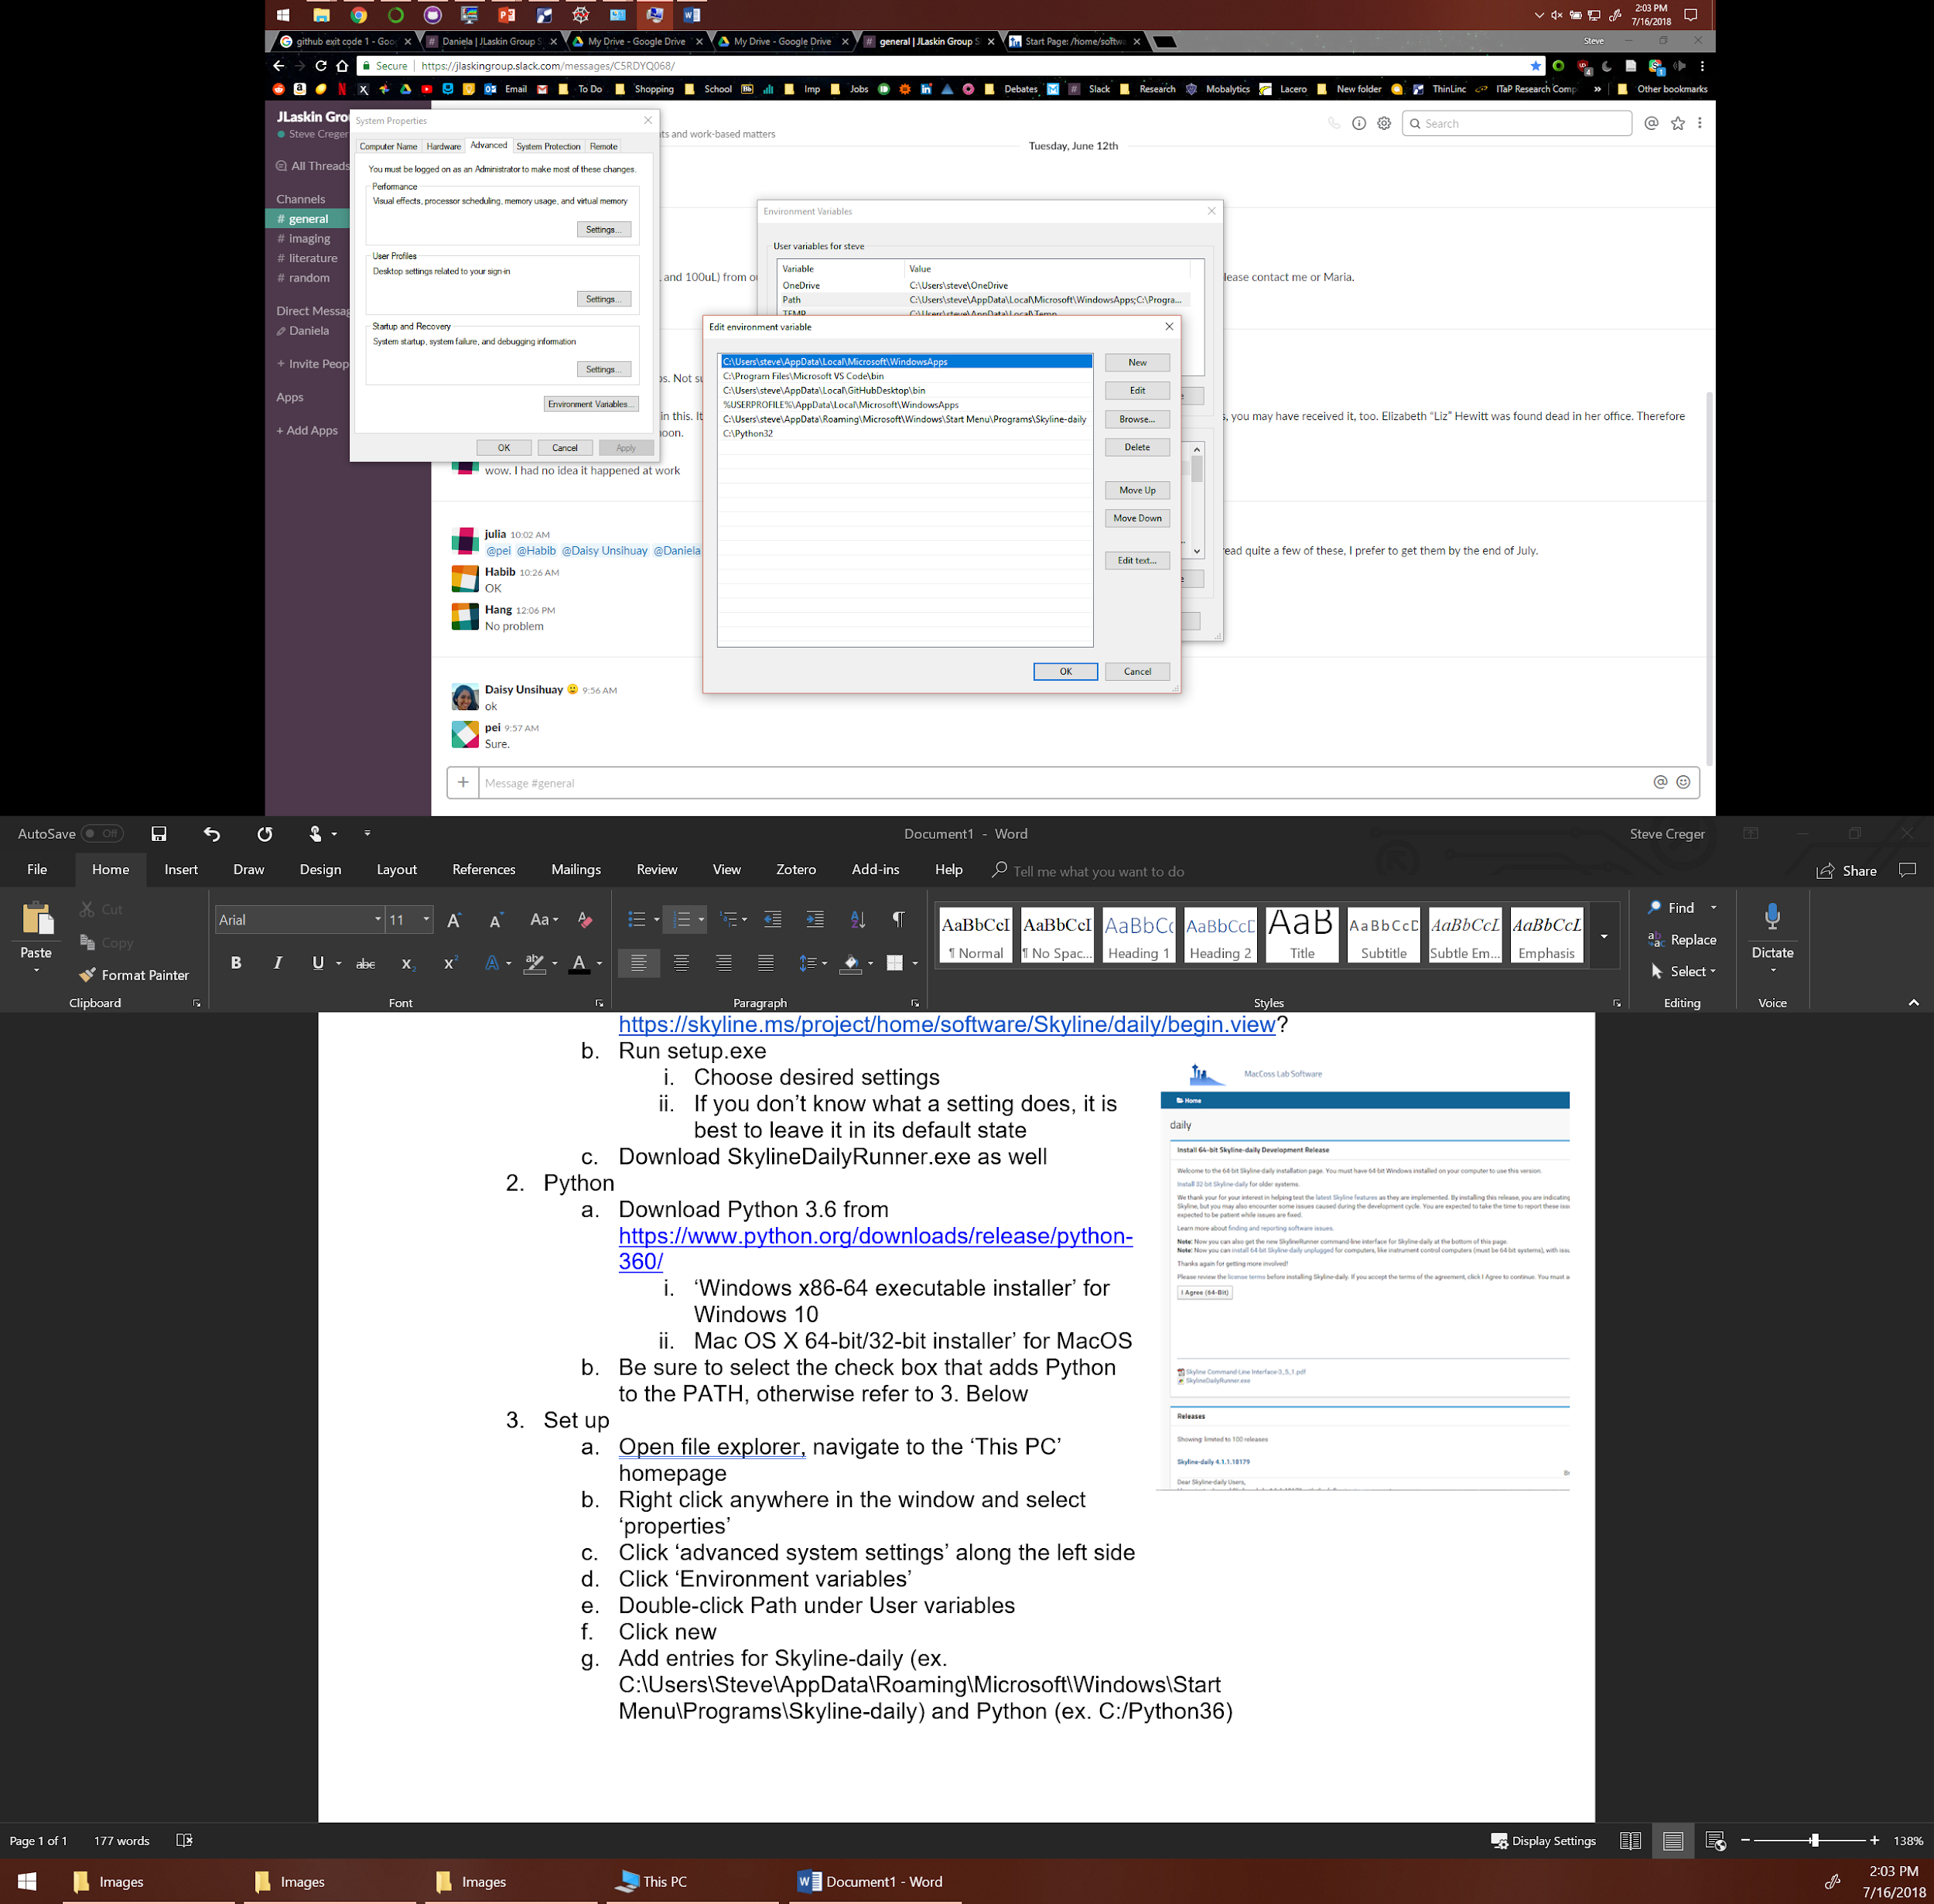
  5. If you don’t: click new
  6. Type the path to the desired program and hit enter
     1. To find the path, navigate to the folder/file in question in Windows File Explorer
     2. In the main toolbar, click 
     3. Paste the entry into the Path table, make sure to remove the “quotation marks”

### MSIC

* 1. Download the MSIC Master folder and copy it into the C: drive. (This way path defaults will work, however if you want to change it refer to f).
  2. Open Anaconda Navigator; perform any updates that it prompts you to
  3. Open (and update) Spyder
  4. Open FirstTimeSetup_ClickMe.py (ctrl + o or File>Open) and then run it (by hitting F5 for Anaconda/Spyder)
  5. Open SETTINGS.txt in the MSIC_Master folder
  6. Change the settings as desired, the order is as follows:

|  |  |  |  |
| --- | --- | --- | --- |
| **Line #** | **Setting** | **More Info** | **Example** |
| 1 | Home Directory | Where post-processed images are saved | C:/MSIC_Master/Data |
| 2 | Skyline Template Path |  | C:/MSIC_Master/Template.sky |
| 3 | SkylineRunner Path |  | C:/MSIC_Master/SkylineDailyRunner.exe |
| 4 | Image Format | This must be an RGBA-compatible format | .png / .tiff (no jpeg) |
| 5 | Color Map Style | Adjust the color of the images produced via Main, Outlier, or AIC methods | hot, magma, plasma, viridis, etc. (the full list of colormap options can be found [here](https://matplotlib.org/examples/color/colormaps_reference.html)) |

# 

# 

# Using the Programs

### Mass Profiler

#### Use

* + 1. File -> Create Project
    2. 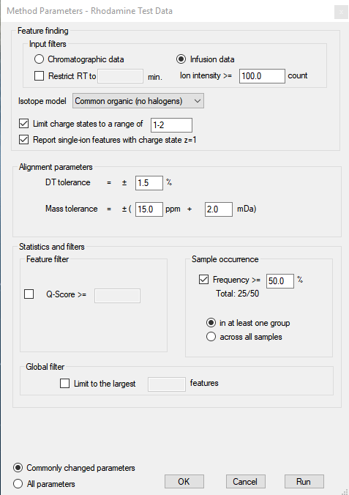Change ‘Number of groups’ to 1
    3. Use a descriptive name for ‘Project Name’ (ex. PC18.1_positive_IM)
    4. Click the ‘Add’ button
    5. Navigate to your data folder
    6. Use ctrl+click or shift+click to add all your data (from one experiment at a time)
    7. Run the method via ‘Open method on OK’ option or by clicking the green play button
    8. File -> Export Feature Summary -> From Table – All Features
    9. Save the feature summary in the same folder as your raw data

#### Settings

* + 1. You should be free to change anything in here but revert to the settings pictured here if you have problems

#### Output

* + 1. An .xlsx report containing characterizing information for each peak

### Skyline

#### Use

* + 1. All taken care of by MSIC, you only have to edit and save the settings for template.sky to have your desired settings

#### Settings

* + 1. Settings > Transition Settings
    2. Default settings are shown in the Appendix

#### Output

* + 1. A tab-separated-value (.tsv) file with characterization and intensity data for every identified peak

### MSIC

#### Use

**Ensure there are no spaces anywhere in your path to the data folder!**

##### Main_ClickMe

* 1. Creates IM-MS images from raw data and a Mass Profiler export
  2. Input: 1+ data folders (raw .d IM-MS data, Mass Profiler export)
  3. Output: Images folder within the data folder, contains an image and txt file for every peak in the experiment
  4. Instructions:
     1. Run the program, enter ‘y’ to change the settings ‘n’ to use the default settings
     2. A new file explorer window should pop up, otherwise click the pulsing orange button on the windows taskbar
     3. Select data folders, each data folder must contain: raw IM-MS data in Agilent .d format and a Mass Profiler Feature Summary (See Mass Profiler above for more info)
     4. Enter your desired aspect ratio(s) as prompted
     5. Sit back, this will take somewhere between 10 and 60 minutes

##### OutlierCorrection_ClickMe

* 1. Remove spikes from images, results in (ideally) more defined images
  2. Input: 1+ txt files corresponding to MSIC images
  3. Output:
     1. Attenuation—Finds the highest peak and scales it back to a user-defined percentage above the 2nd highest peak. Works well for images with only 1 spike
     2. Global Mean—Don’t use this, it flags too many outliers in dark images and results in an overly smooth image
     3. Local Mean—This is personally my favorite spike correcting algorithm. Finds outliers by comparing each pixel to the mean intensity and standard deviation of its neighbours within a box of user-defined size. Bigger boxes mean more smoothing. Outliers have their intensity set equal to the median of their 8 nearest neighbours. Images are saved in the home directory and tagged as ‘OutlierAlgorithmType’

##### AbsoluteImageComparison_ClickMe

* 1. Allow for comparison between images by setting their color scale equal
  2. Input:
     1. 2+ txt files corresponding to MSIC images
     2. 2 folders of experimental data that has already been processed by Main_ClickMe
  3. Output:
     1. 2+ images with each having the same color scale, you will be prompted for the save location
        1. A new folder called ‘Exp01 vs Exp02’ in your home directory. This folder is full of images corresponding to compounds that were common between both input folders. Each compound has its intensities scaled according to the highest intensity between itself and its matching compound in the other folder

##### ChangeAspectRatio_ClickMe

* + - 1. Change the aspect ratio of a whole experimental folder
      2. Input: The Images folder within an experimental folder
      3. Output: The same folder with all the images resized to your desired aspect ratio

##### CreateRGB_ClickMe

* + - 1. Creates 1 image wherein each of the red, green, and blue channels for each pixel is determined by the relative intensity of a separate compound at a given point
      2. Input: 3 .txt files corresponding to MSIC images
      3. Output: 1 image, will prompt you to select the save location
      4. The order that you input the images determines which one becomes red, which becomes blue, and which becomes green

# 

# 

# Troubleshooting

1. Make sure Python version == interpreter Python version, otherwise everything should work on the most up to date versions but, just in case, you can revert back to these tested versions

|  |  |
| --- | --- |
| **Software** | **Version** |
| Mass Profiler | B.08.01 8.1.150.0 |
| Skyline Daily | 4.1.1.18179 |
| SkylineDailyRunner | 3.5.1 |
| Python | 3.6.5 |
| Anaconda | 5.2 (for Python 3.6) |
| Spyder | 3.3.0 |

1. ValueError: could not convert string to float: '#N/A
   1. Open template.sky and manually add your data and export a report
   2. This usually fixes it, otherwise uninstall/reinstall Skyline
2. Python errors:
   1. Open ‘Anaconda Prompt’ and enter ‘conda update --all’
   2. Un/reinstall Anaconda
   3. Use a different Python interpreter

Appendix

Default Skyline Settings